***PF Lab task 10***

1. Declare a structure named employee that stores the employee id, name, salary and department.

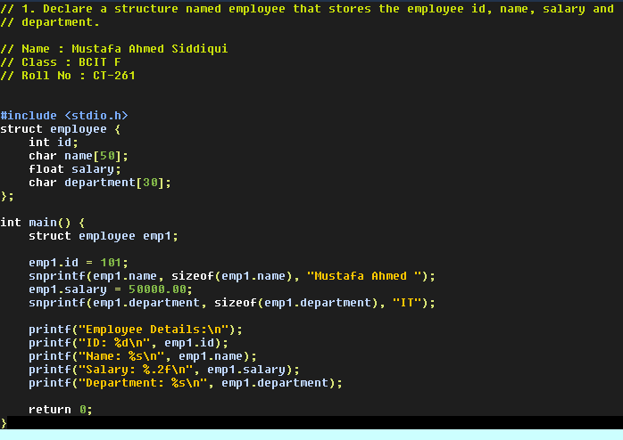

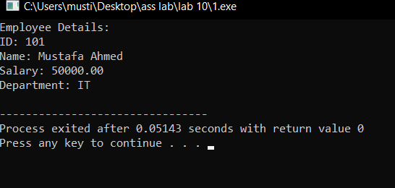

1. Take data input from user after declaring a variable of employee type and show the data in proper format on output screen.

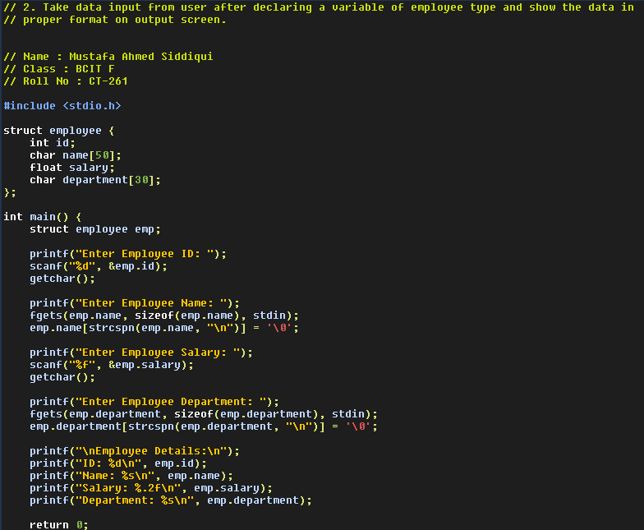

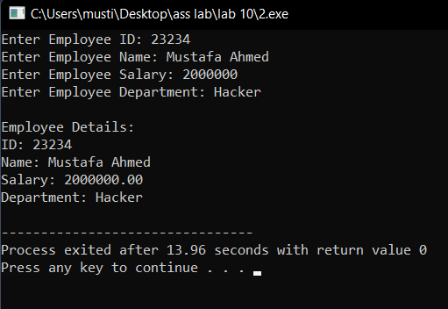

1. A phone number, such as (212) 767-8900, can be thought of as having three parts: e.g., the area code (212), the exchange (767), and the number (8900). Write a program that uses a structure to store these three parts of a phone number separately. Call the structure phone. Create two structure variables of type phone. Initialize one, and have the user input a number for the other one. Then display both numbers. The interchange might look like this: Enter area code: 415 Enter exchange: 555 Enter number: 1212 Then display like below: My number is (212) 767-8900 Your number is (415) 555-1212.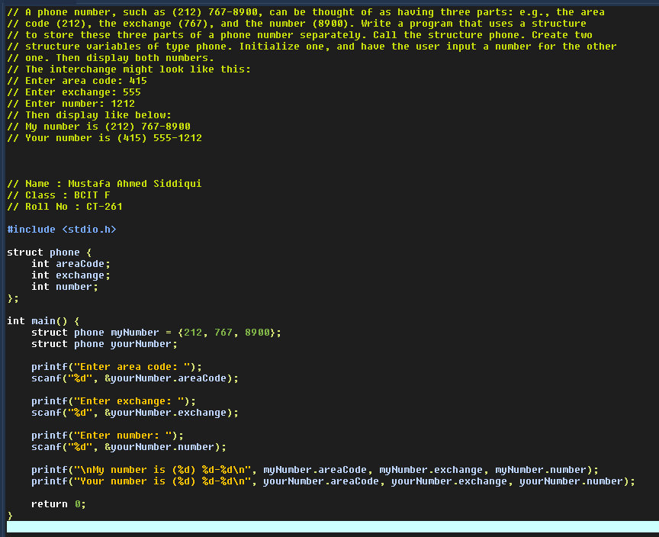

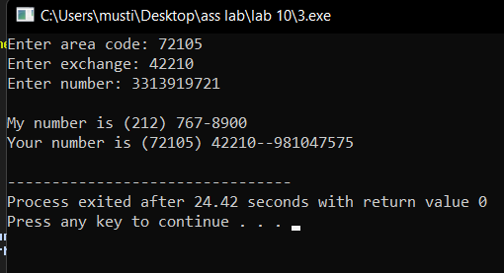

1. Define a structure to store the following student data: CGPA, courses (course name, GPA), address (consisting of street address, city, state, zip). Input 2 student records, compare and display which student have highest GPA in which course also Display which student has the highest CGPA . HINT: define another structure to hold the courses and address.

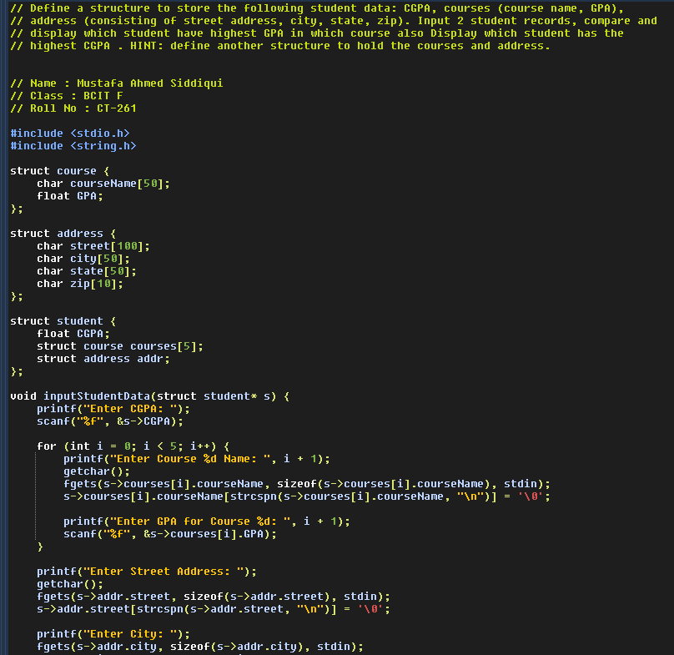

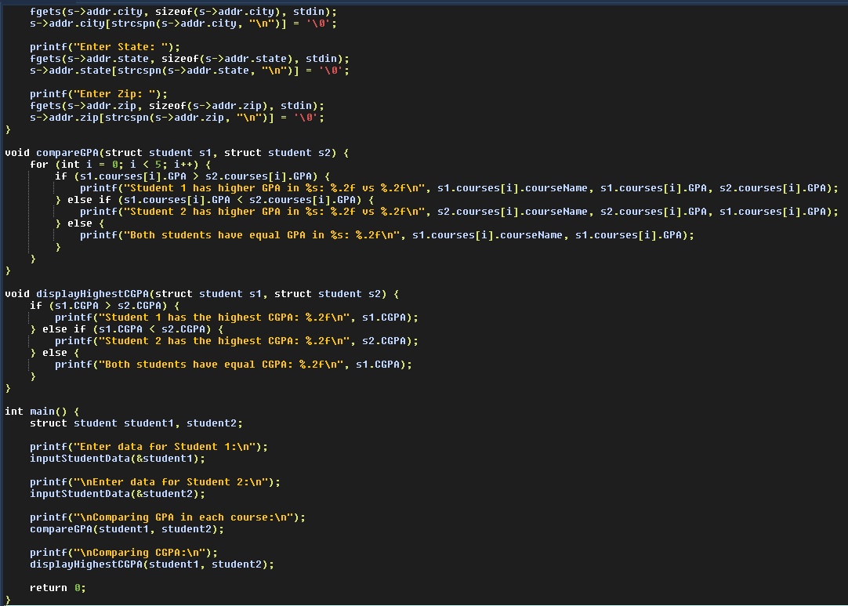

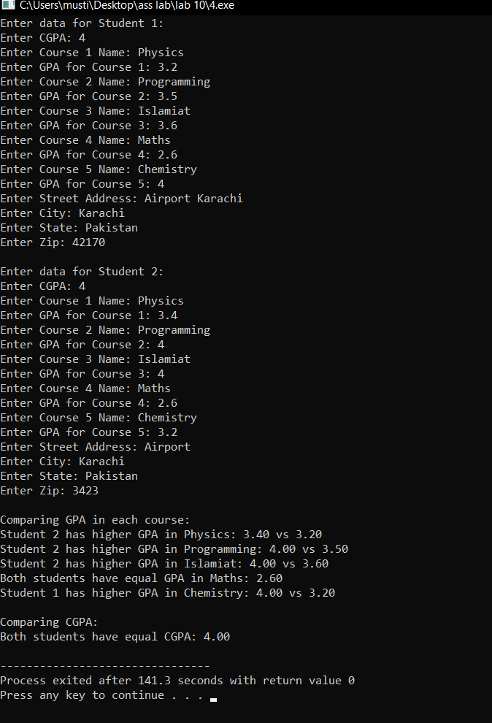

1. Write a C program that uses functions to perform the following operations: i) Reading a complex number ii) Writing a complex number iii) Addition of two complex numbers iv) Multiplication of two complex numbers (Note: represent complex numbers using a structure..

